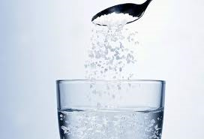
A substance that dissolves in a liquid is said to be soluble in that liquid. The dissolved substance forms a solution. The soluble substance that dissolves is called the solute. The solvent is the substance that dissolves the solute. In a cup of coffee the solvent is water and the two solutes are coffee and sugar.

forms, a, are, is, be, and, that, of,

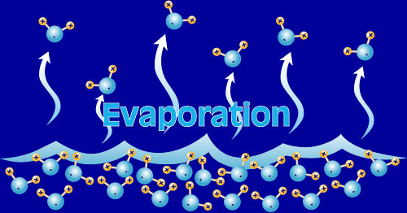
Evaporation can be used to separate solutions such as salt dissolved in water. The solution is left in the Sun to allow the water to change its state to gas and leave the salt behind. With this method the solvent is lost to the atmosphere and the solute is collected. Evaporation works on mixtures.
is, on, in, can, to, and, its, as, the,

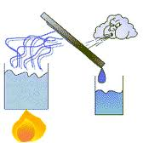
Distillation is similar to evaporation except that when the solvent is changed to a gas it is collected in a separate container and cooled back to a liquid. The result is both the solvent and solute can be collected again. Distillation works on mixtures.

to, is, and, the, on, that, in, a, it,

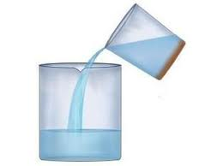
Decantation is used to separate a heavy insoluble solid from a liquid. The solid is allowed to sink to the bottom of the container and then the solvent is poured off, leaving the solid behind in the container. Sand and water can usually be separated in this way.

is, of, a, in, and, from, off, used, to, the,

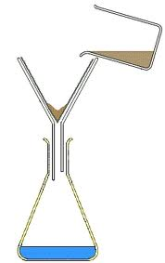
Filtration is used to separate a fine insoluble solid from a liquid. The liquid with the solid suspended in it is poured through a filter paper which allows the solvent to pass through and catches the solid. Muddy river water can be filtered.

with, be, the, it, to, and, from, a,


Chromatography is a method of separating substances that only occur in small amounts in a mixture. The substance in a liquid form is allowed to pass through a special paper. The different molecules travel different distances through the paper and show up as coloured bands.

in, of, to, up, only, a, the,

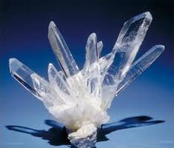
Crystallisation is a technique used to separate a compound from a solution. Compounds tend to be more soluble in hot liquids than cold liquids. If a saturated hot solution is allowed to cool, the solute is no longer soluble in the solvent and forms crystals of pure compound. The crystals can be collected by filtration.

tend, no, a, in, of, is, to, be, the,

